

# 

Project and Professionalism

(6CS007)

Milestone 3

Music Recommendation System (Oni Music)

Student Id : 2051814

Student Name : Sakshyam Shrestha

Section : L6CG7

Supervisor : Prakash Dahal

Reader : Deepson Shrestha

Submitted On : 24th January 2022

Table of Contents

Table of Figures 3

1. Functional Decomposition Diagram (FDD) 1

2. Software Requirement Specification (SRS) 2

2.1. User Management System (UM) 2

2.2. Recommendation Management System (RM) 3

2.3. Genre Management System (GM) 3

3. Activity Diagrams 4

3.1. User Management System 4

3.1.1. User Registration 4

3.1.2. User Login 5

3.1.3. User Logout 5

3.1.4. User Password Reset 6

3.2. Recommendation Management System 6

3.2.1. Search Query 6

3.2.2. Song Recommendation 7

3.3. Genre Management System 7

3.3.1. Genre Display 7

3.3.2. Genre Search 8

4. Use Case Diagrams 9

4.1. User Management System 9

4.2. Recommendation Management System 10

4.3. Genre Management System 11

5. Sequence Diagram 12

5.1. User Management System 12

5.1.1. User Registration 12

5.1.2. User Login 13

5.1.3. User Logout 14

5.1.4. User Password Reset 15

5.2. Recommendation Management System 16

5.2.1. Search Query 16

5.2.2. Song Recommendation 16

5.3. Genre Management System 16

5.3.1. Genre Display 16

5.3.2. Genre Search 16

6. Wireframes 16

6.1. Homepage 16

6.2. About Page 17

6.3. Login Page 17

7. Signup Page 18

7.1. Genre Page 18

8. Entity Relationship Diagram (ERD) 19

9. Data Dictionary 19

9.1. User 19

10. Class Diagram (CD) 21

# Table of Figures

Figure 1: Functional Decomposition Diagram (FDD) 1

Figure 2: Legend 2

Figure 3: User Registration (Activity Diagram) 4

Figure 4: User Login (Activity Diagram) 5

Figure 5: User Logout (Activity Diagram) 5

Figure 6: User Password Reset (Activity Diagram) 6

Figure 7: Search Query (Activity Diagram) 6

Figure 8: Song Recommendation (Activity Diagram) 7

Figure 9: Genre Display (Activity Diagram) 7

Figure 10: Genre Search (Activity Diagram) 8

Figure 11: User Management (Use Case Diagram) 9

Figure 12: Recommendation Management (Use Case Diagram) 10

Figure 13: Genre Management (Use Case Diagram) 11

Figure 14: User Registration (Sequence Diagram) 12

Figure 15: User Login (Sequence Diagram) 13

Figure 16: User Logout (Sequence Diagram) 14

Figure 17: Password Reset (Sequence Diagram) 15

Figure 18: Homepage (Wireframe) 16

Figure 19: About page (Wireframe) 17

Figure 20: Login page (Wireframe) 17

Figure 21: Signup page (Wireframe) 18

Figure 22: Genre page (Wireframe) 18

Figure 23: System ERD 19

Figure 24: System Class Diagram 21

# Functional Decomposition Diagram (FDD)

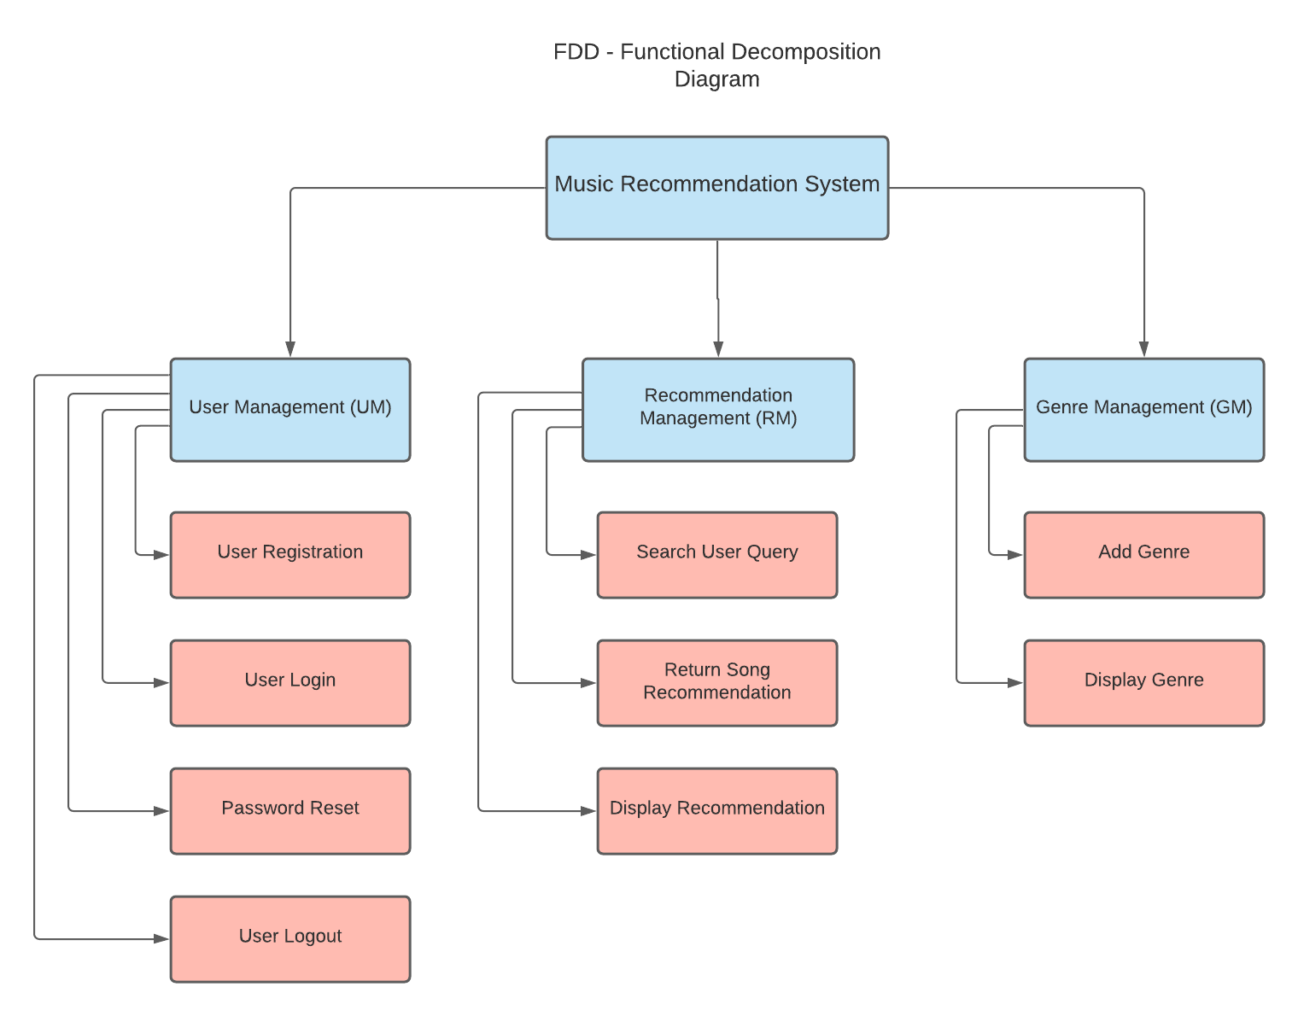

Figure 1: Functional Decomposition Diagram (FDD)

# Software Requirement Specification (SRS)

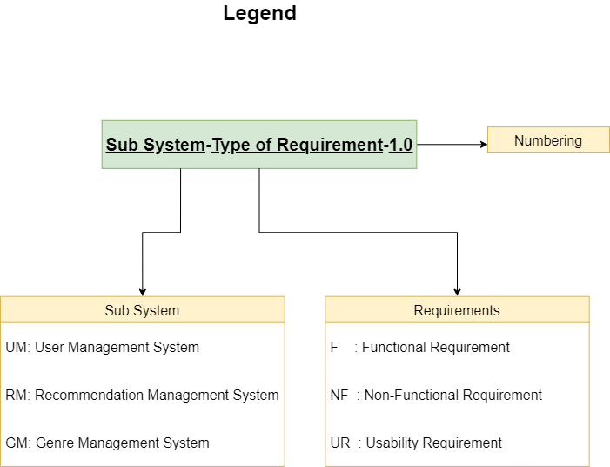

Figure 2: Legend

# User Management System (UM)

|  |  |  |  |
| --- | --- | --- | --- |
| Requirement Code | Requirement Description | Use Case | MoSCoW Prioritization |
| UM-F-1.0 | The user should be able to create a new user account. | Create User | Must have |
| UM-NF-1.1 | While creating a user, the username must be less than 150 characters and only include letters, digits and @/. /+/-/_ only. |  | Must have |
| UM-F-2.0 | The user should be able to logout of the system. |  | Must have |
| UM-F -2.1 | The user should be able to logout of the account that they are logged in. |  | Must have |
| UM-F-3.0 | The system should allow the user to reset their password. |  | Must have |
| UM-NF-3.1 | While resetting the user password, the user must be logged into the related account. |  | Must have |

# Recommendation Management System (RM)

|  |  |  |  |
| --- | --- | --- | --- |
| Requirement Code | Requirement Description | Use Case | MoSCoW Prioritization |
| RM-F-1.0 | The user should be able to search for desired song. | Create search query | Must have |
| RM-NF-1.1 | While searching, the user must insert the name of a song track. |  | Should have |
| RM-F-2.0 | The user should be able to acquire music recommendation based on the search query. |  | Must have |

# Genre Management System (GM)

|  |  |  |  |
| --- | --- | --- | --- |
| Requirement Code | Requirement Description | Use Case | MoSCoW Prioritization |
| GM-F-1.0 | The user should be able to browse the genre page. | Create genre view | Must have |
| GM-F-2.0 | The user should be able to search for specific genre. |  | Must have |

# Activity Diagrams

## User Management System

### User Registration

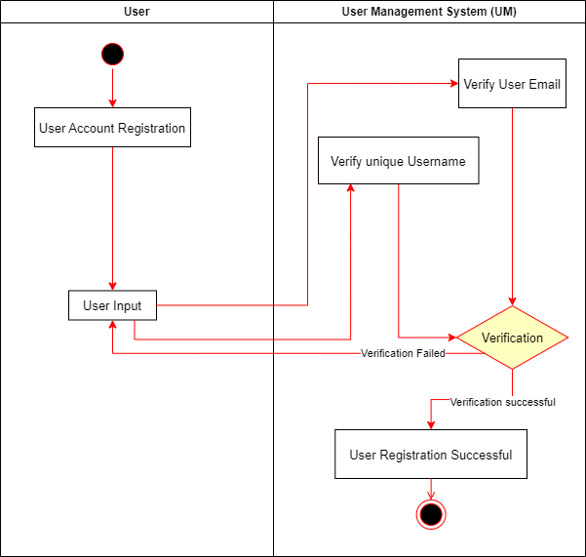

Figure 3: User Registration (Activity Diagram)

### User Login

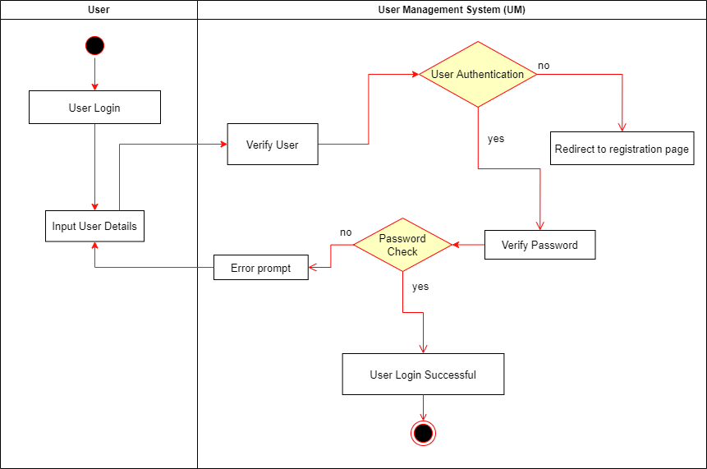

Figure 4: User Login (Activity Diagram)

### User Logout

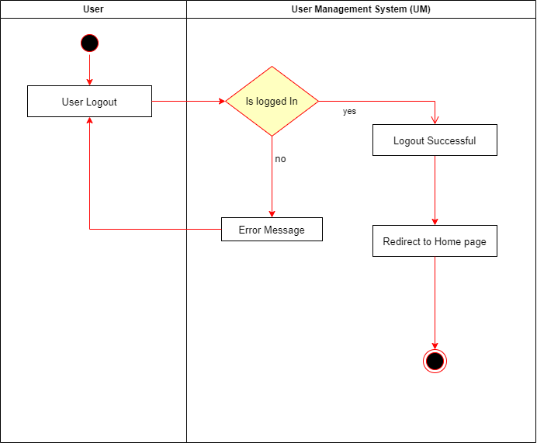

Figure 5: User Logout (Activity Diagram)

### User Password Reset

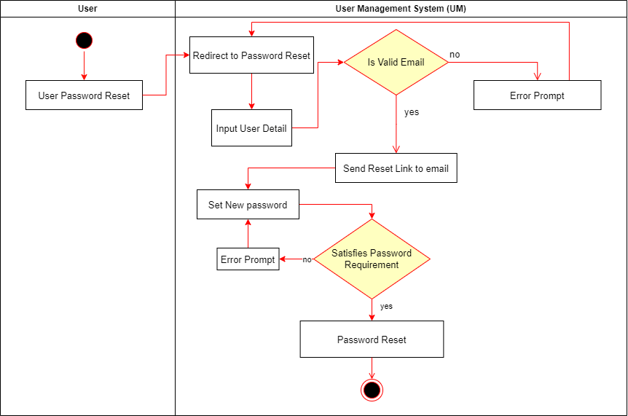

Figure 6: User Password Reset (Activity Diagram)

## Recommendation Management System

### Search Query

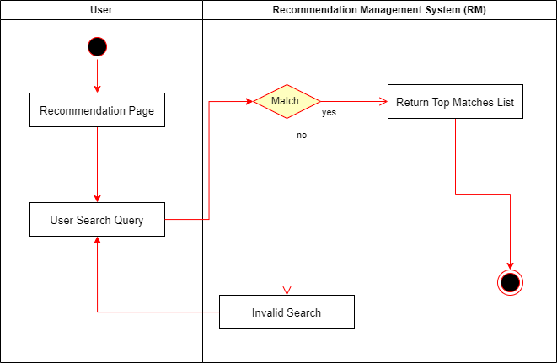

Figure 7: Search Query (Activity Diagram)

### Song Recommendation

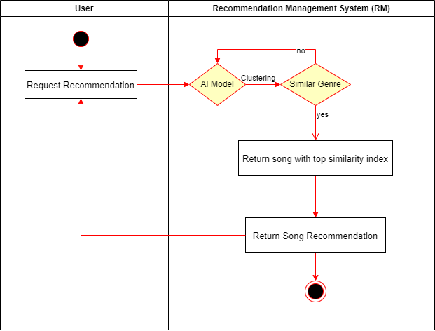

Figure 8: Song Recommendation (Activity Diagram)

## Genre Management System

### Genre Display

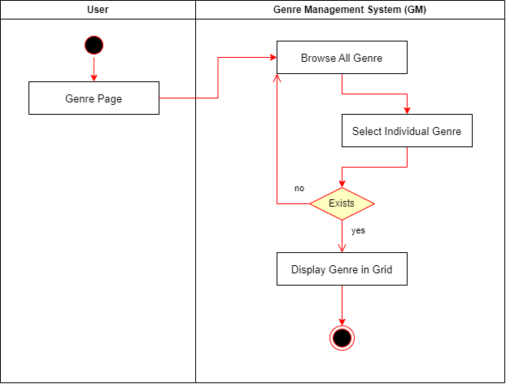

Figure 9: Genre Display (Activity Diagram)

### Genre Search

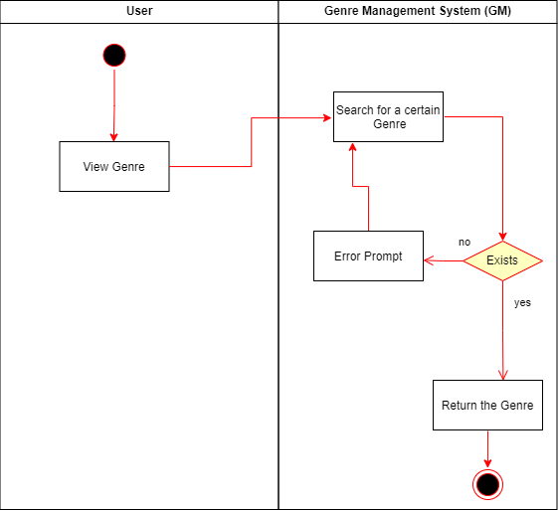

Figure 10: Genre Search (Activity Diagram)

# Use Case Diagrams

## User Management System

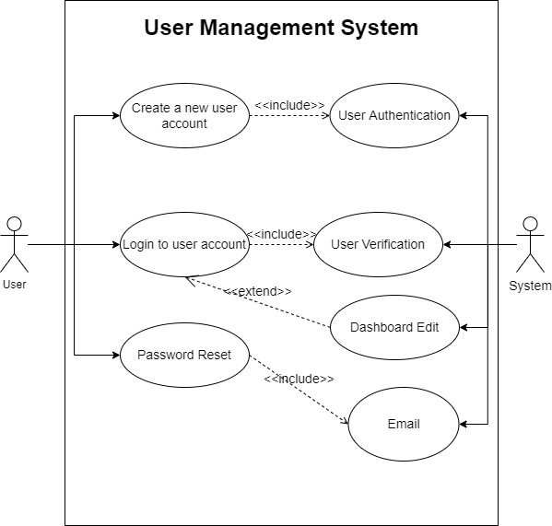

Figure 11: User Management (Use Case Diagram)

## Recommendation Management System

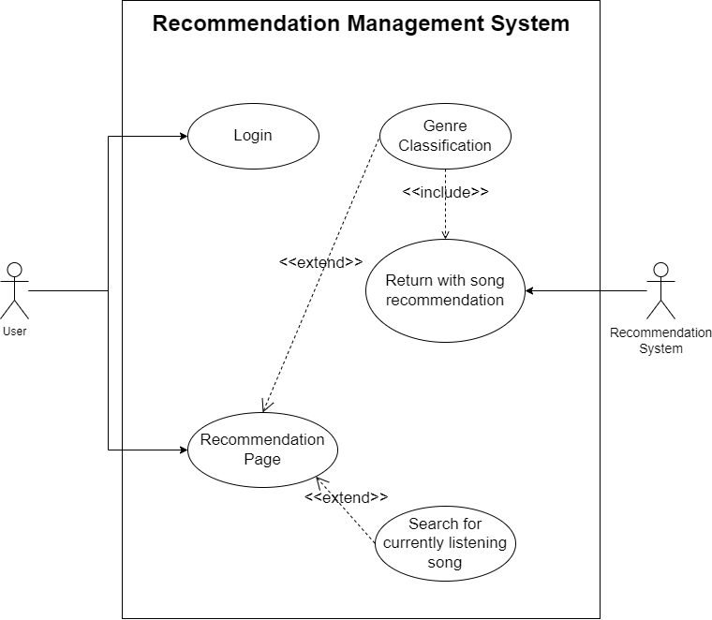

Figure 12: Recommendation Management (Use Case Diagram)

## Genre Management System

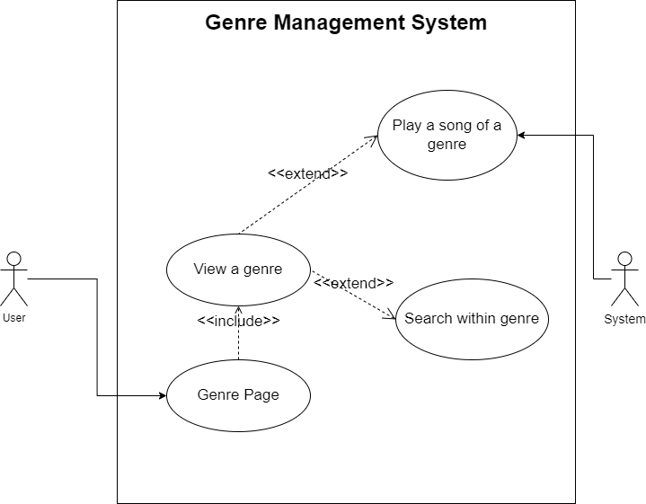

Figure 13: Genre Management (Use Case Diagram)

# Sequence Diagram

## User Management System

### User Registration

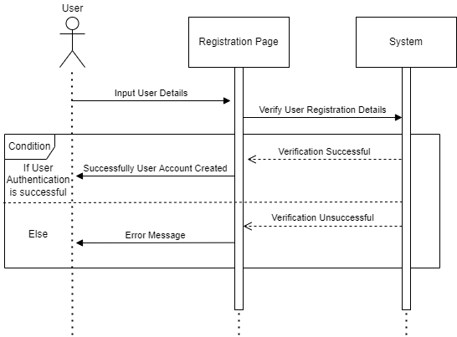

Figure 14: User Registration (Sequence Diagram)

### User Login

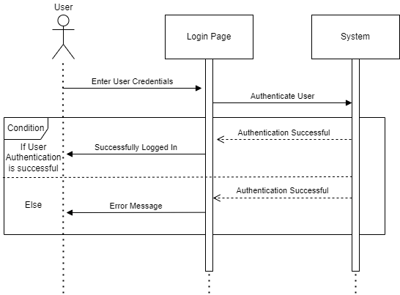

Figure 15: User Login (Sequence Diagram)

### User Logout

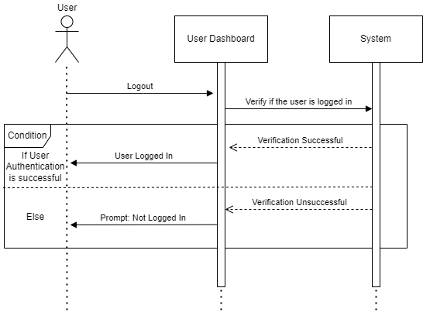

Figure 16: User Logout (Sequence Diagram)

### User Password Reset

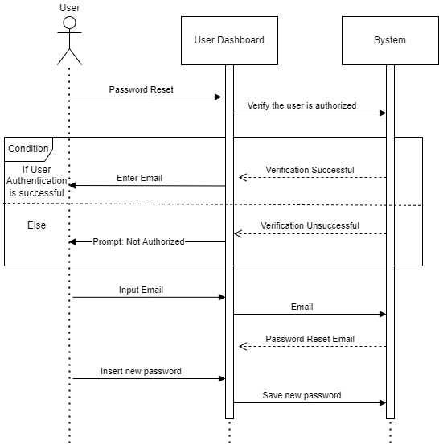

Figure 17: Password Reset (Sequence Diagram)

## Recommendation Management System

### Search Query

### Song Recommendation

## Genre Management System

### Genre Display

### Genre Search

# Wireframes

## Homepage

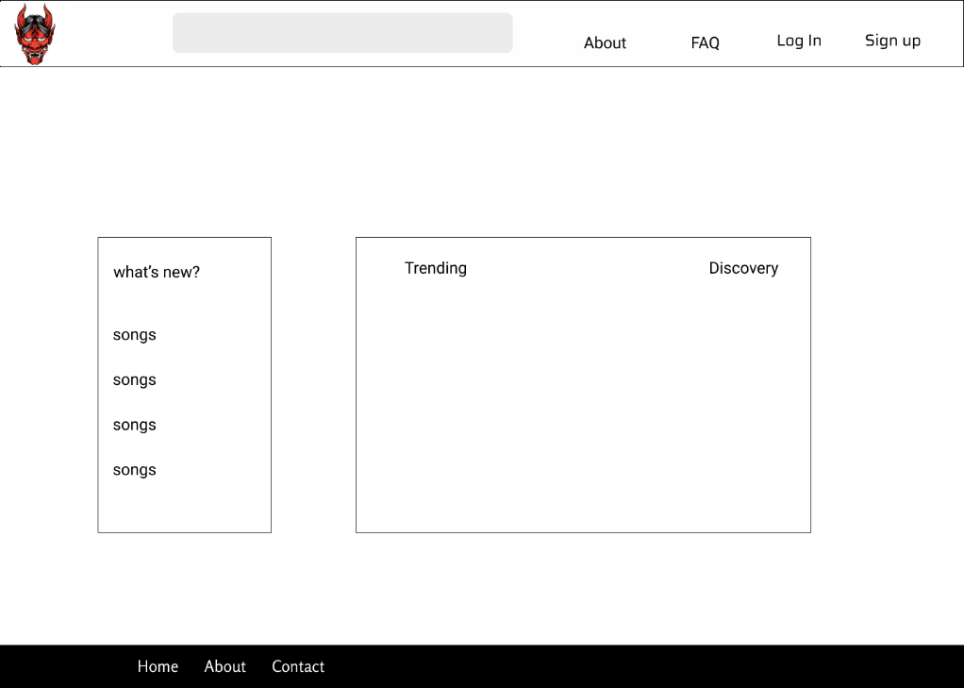

Figure 18: Homepage (Wireframe)

## About Page

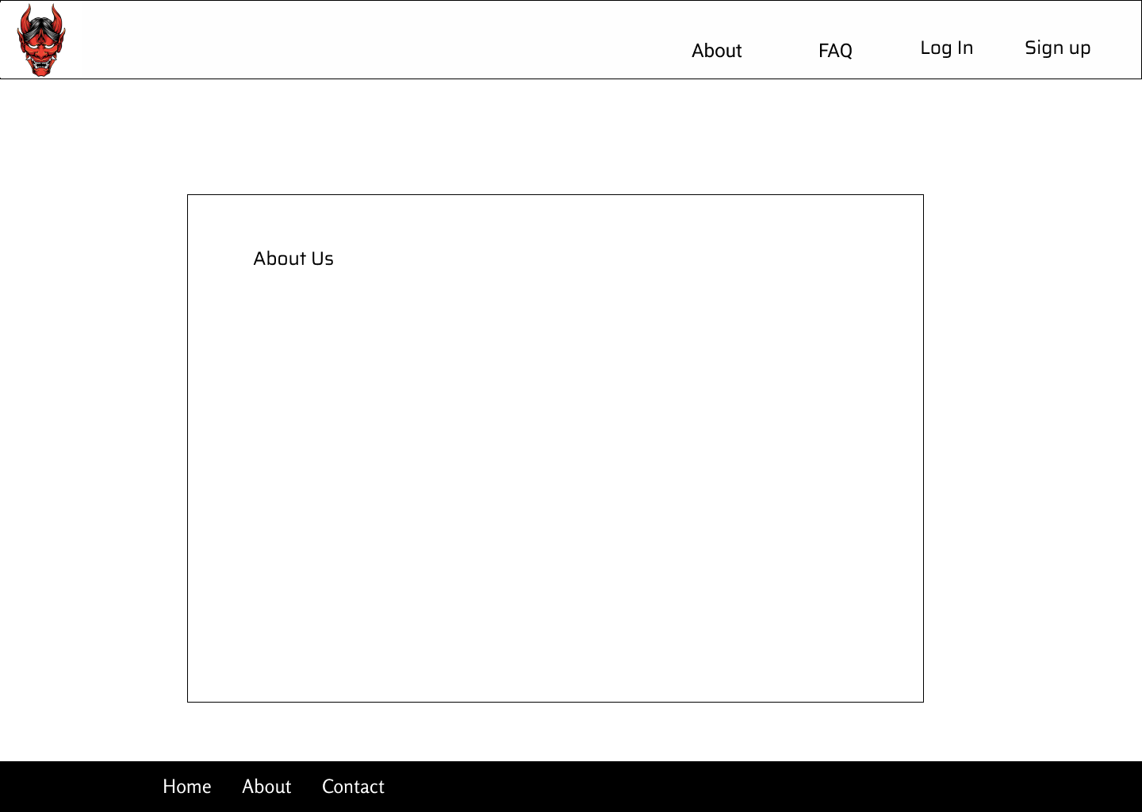

Figure 19: About page (Wireframe)

## Login Page

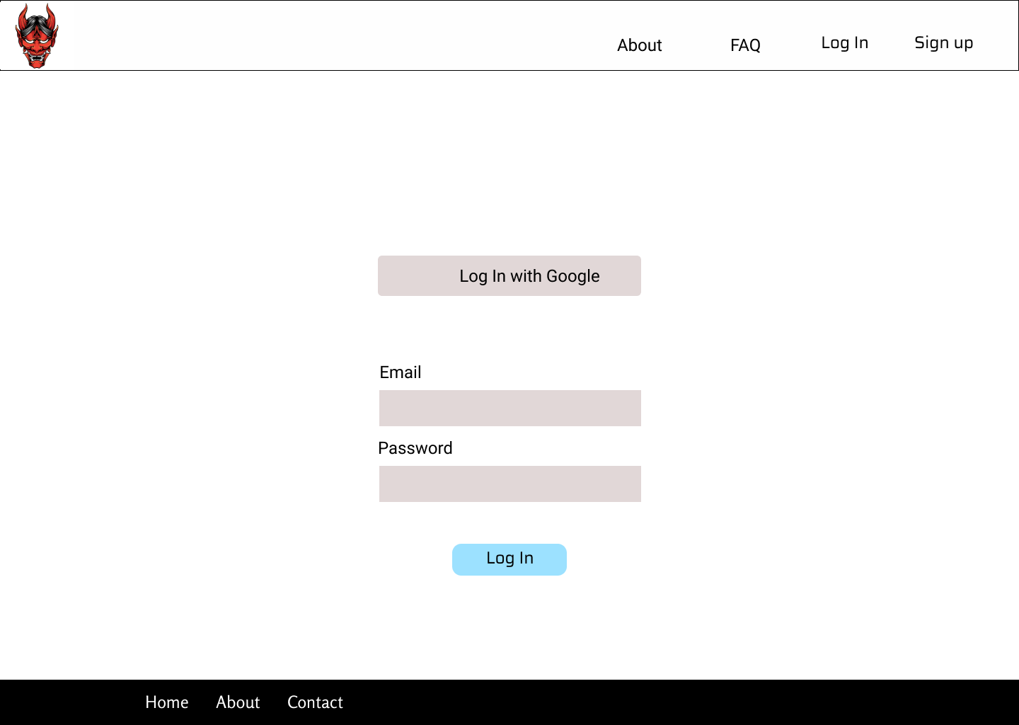

Figure 20: Login page (Wireframe)

## Signup Page

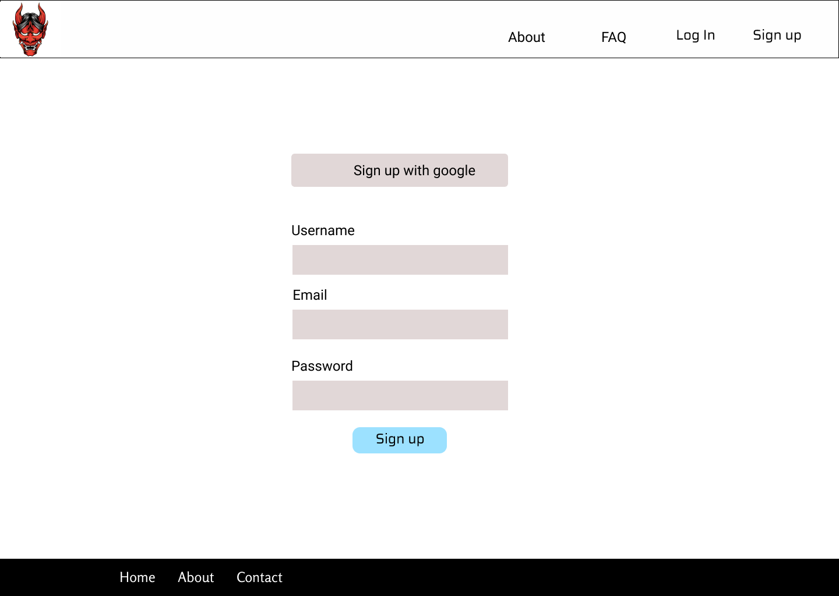

Figure 21: Signup page (Wireframe)

## Genre Page

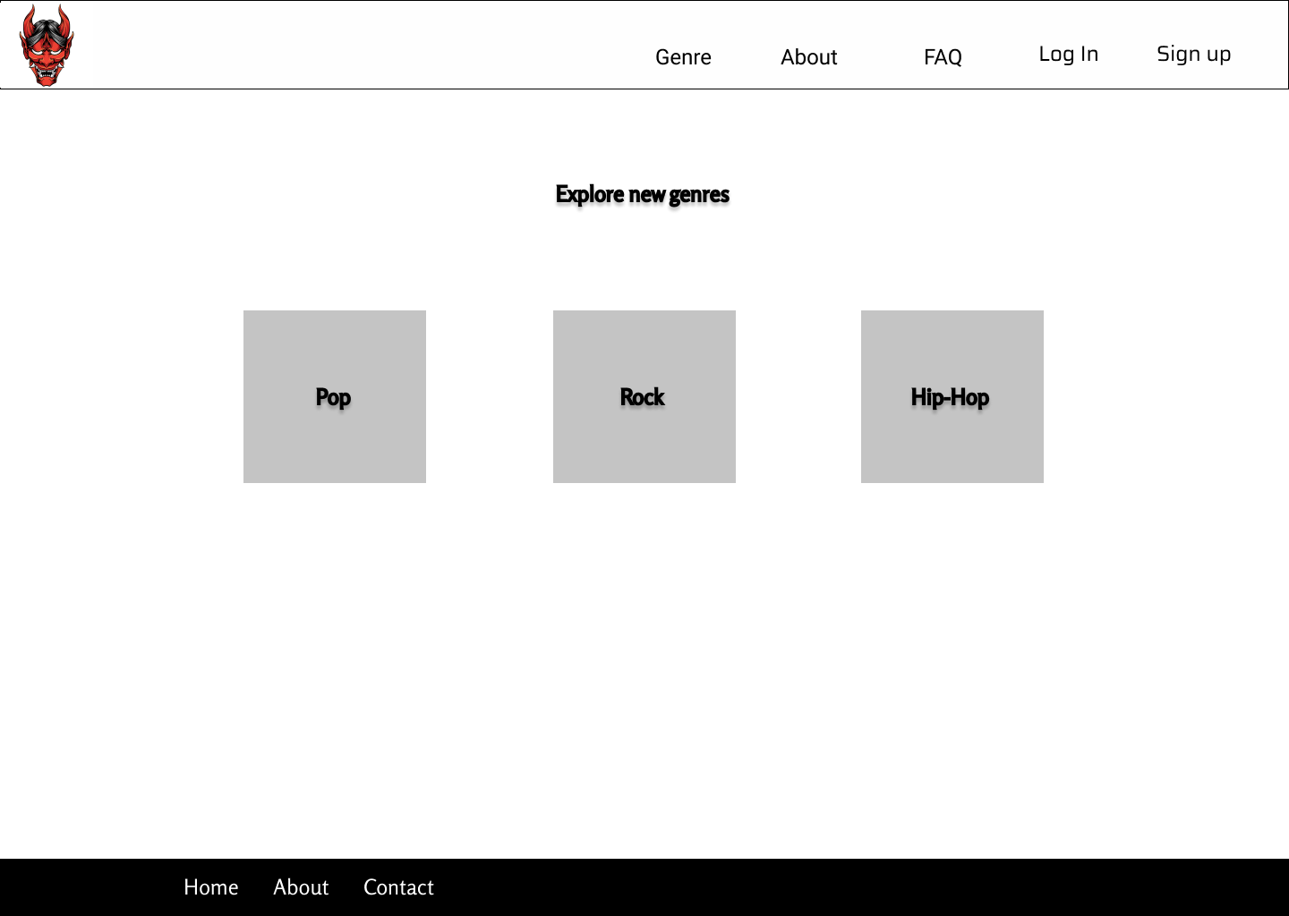

Figure 22: Genre page (Wireframe)

# Entity Relationship Diagram (ERD)

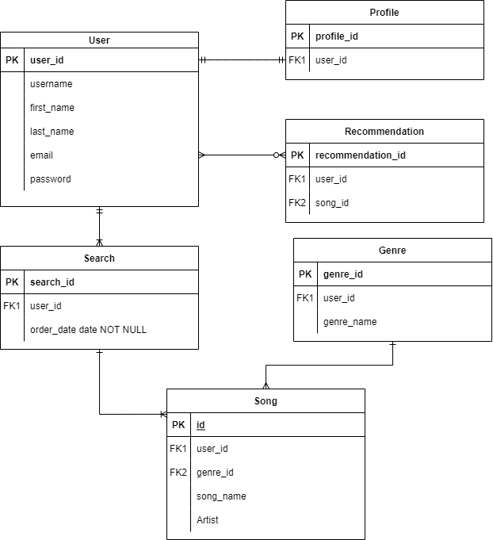

Figure : System ERD

# Data Dictionary

## User

|  |  |  |  |  |
| --- | --- | --- | --- | --- |
| Name | Data Type | Size | Description | Key |
| user_id | int | 8 | Unique user id | Primary |
| firstname | char | 20 | First name of the user |  |
| lastname | char | 20 | Last name of the user |  |
| email | char | 20 | Email of the user |  |
| password | char | 20 | Password of the user account |  |

# Class Diagram (CD)

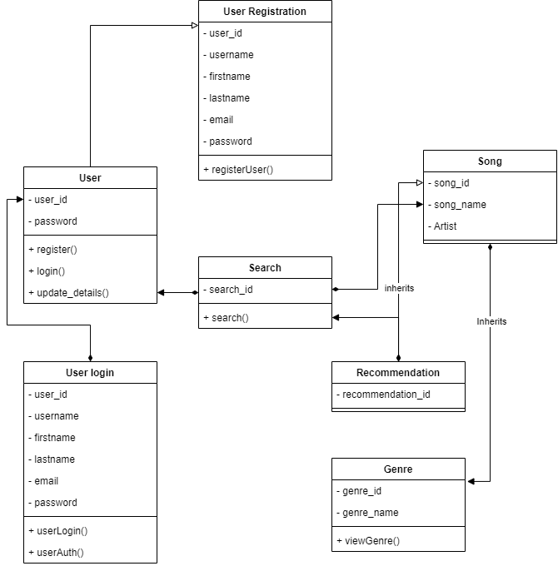

Figure : System Class Diagram